StopGap Sheffield

Trustees’ Annual Report & Accounts

2019-2020

Trustees’ Annual Report and Financial Report
For the period 1 July 2019 to 30 June 2020

Charity Reference and Administration

Registered Number: 1146601

Registered: 27 March 2012

Registered office:

Sheffield Cathedral

Church Street

Sheffield S1 1HA

Trustees (including officers):

Jo Abbott Chair

David Peers

Louise Finnigan Secretary

Barney Williams Treasurer

Tina Powell-Wiffen

Souleymane Bah

Timothy Renshaw

Aimee Lowe

Administrator (part time):

Liz Grasso

Bankers:

Yorkshire Bank
Fargate
Sheffield S1 1LL

Note: Public Benefit:
In compiling this report and in exercising their powers and duties, the Trustees have had due regard to the guidance on public benefit published by the Charity Commission.

Structure, Governance and Management

Governing Document:

StopGap Sheffield is a Charitable Association whose constitution was adopted on the 4th October 2011 and amended by a Resolution passed at a Special General Meeting on the 28th February 2012.

Governance and Management:

The Charity and its property are managed and administered by trustees comprising its officers and other trustees elected at the last Annual General Meeting or co-opted during the year. All trustees must retire at each Annual General Meeting but are eligible for re-election. The day to day running of the Charity is the responsibility of its officers (the Chair, Secretary and Treasurer). The trustees meet regularly and receive reports from the officers and from other appropriate persons on the operations of the Charity, its finances, fundraising and governance. The trustees take decisions regarding strategic and policy direction, significant items of expenditure and other major issues.

Objectives, Activities and Achievements

Charitable Objectives:
The objectives of StopGap Sheffield (hereinafter referred to as StopGap), as stated in its constitution, are 'the relief of poverty of the homeless, temporary homeless and rough sleepers in the City of Sheffield by the provision of overnight emergency accommodation and related support services.

Method of operation:
StopGap arranges and pays for short-term overnight accommodation in Sheffield for those who may otherwise find themselves on the streets or sleeping rough. Accommodation is in private B&Bs approved both by Sheffield City Council and ourselves. We do not possess, hire, or otherwise provide our own accommodation. StopGap liaises closely with various local voluntary sector agencies accepting referrals from them of individuals as appropriate (and subject to availability in all cases), usually for one night at a time and usually for a maximum of 3 nights per individual within any six-month period. Individuals are asked to report back to the referral agency, or to another appropriate agency, the following day; and must be re-referred by an appropriate agency for a subsequent night's stay. StopGap itself does not select, engage with or interview people directly. The referral process is run via a mobile phone. For most of the current year this was done by our part-time administrator, assisted by a rota drawn from our volunteer trustees. We have no office or permanent staff, other than a part-time administrator as circumstances permit, and currently have no other volunteers.
2020 - A year like no other with a Covid 19 global pandemic and full lockdown of the Country. How Sheffield helped the homeless and rough sleepers:
At the start of the Covid 19 lockdown measures April 2020, Help Us Help, a partnership which brings together the projects of the Cathedral Archer Project, Ben’s Centre, St Wilfrid’s Centre, Sunday Centre and HARC with the Sheffield City Council and its providers such as Framework (the Rough Sleeper Outreach Service) delivered a Meals on Wheels service to a group of vulnerable service users identified as needing care and support whilst the regular services were suspended due to the Covid outbreak. There were also worries from the projects and the Council about health within the homeless community and death in numbers from Covid were feared. Volunteers to provide this service were drawn from these projects as well as Wednesday Night Soup Kitchen, Good News Café and Revive Café.

With the help of around 8-10 volunteers a day, using donated food from Fareshare and other providers, we delivered hot meals to around 70 individuals across four accommodation providers 7 days a week. From 6/4/20-2/8/20 we prepared around 7,369 meals – some of which were breakfasts and lunches for a ‘walk up’ service for people using the Archer Project. We also worked closely with Framework to ensure that they provided food to rough sleepers via their outreach workers. From 3/8/20- 28th August 564 lunches were made by volunteers at St Gabriel's Church and taken out to the hostels and supported accommodation.

In addition to the provision of food, Ben’s Centre and St Wilfrid’s Centre arranged a collection and distribution of toiletries, clothes, DVD players, board games and books.

Achievements for the year 1 July 2019 to 30 June 2020:
2020 has proved to be an interesting year for Stop Gap and other charities with the Covid 19 Pandemic.
However, as a charity, Stop Gap have :
- Updated the Stop Gap web site- https://www.stopgapsheffield.org/
- Worked with Sheffield Hallam University students at collecting the latest evidence of homelessness within the UK and Sheffield. This included students working with Framework and gaining greater insight into local issues. A report was subsequently provided for the Stop Gap Board of Trustees.
The above evidence was used in Stop Gap news updates and funding grant applications.
- Stop Gap have been successful at obtaining funding from grant applications (see updates later)
- Stop Gap have had a “sponsor a room ” campaign
Despite a global Pandemic the Trustees met regularly via zoom and Microsoft meetings. All the trustees had a steep learning curve to get to grips with the technology !
Issues:
The use of StopGap beds up until March 2020 substantially increased. In September 2019 Sheffield had 27 rough sleepers and in September 2020 this had risen to 60. This led to funding pressures on the StopGap account. The trustees agreed an emergency plan including starting to priorities women, operating over the winter months only and as a last resort all activity would stop. Thankfully grant applications started to come in which meant none of the above had to be activated in the end.
During lockdown StopGap beds were still being used despite Sheffield Council having a Duty of Care to house homeless and rough sleepers.

During the 12-month period from 1 July 2019 to 30 June 2020, StopGap provided a total of 737 bed nights for a total of 305 individuals: an average stay of slightly over two nights per individual.

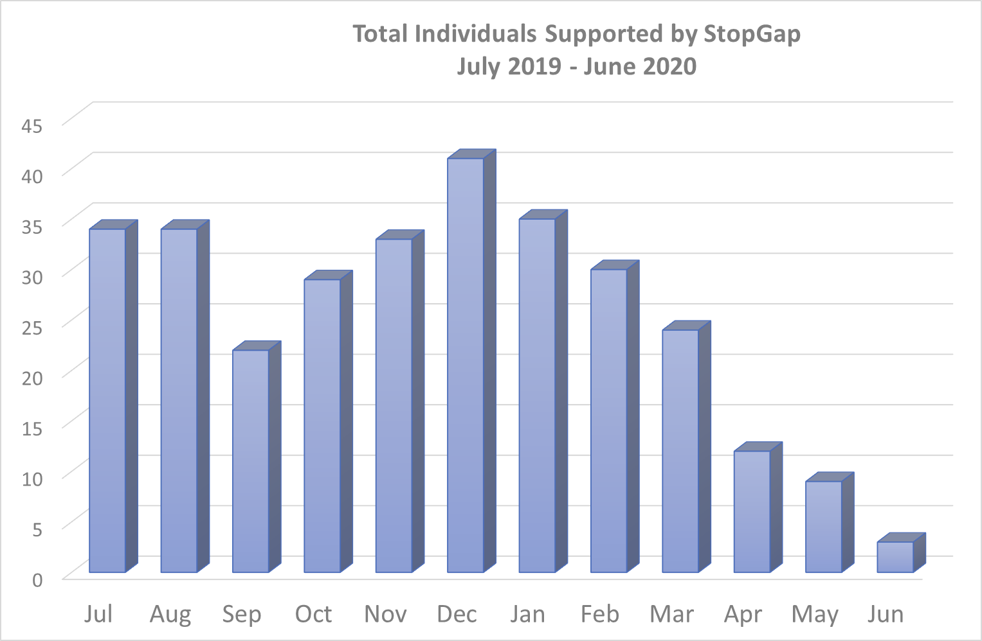

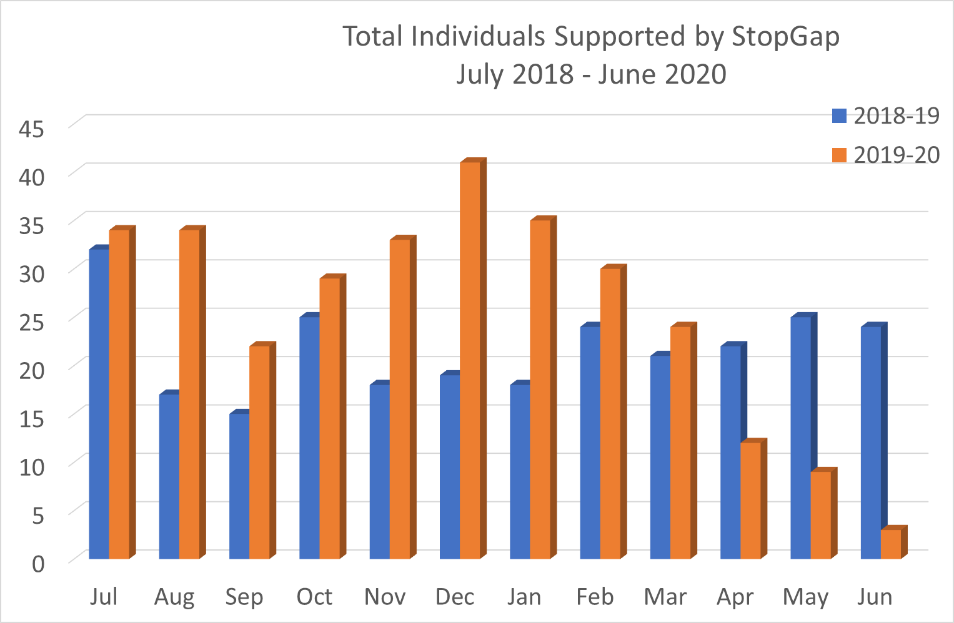

Bednights during the Winter months increased in 2019/20 especially in November to January. Over the last year the number of StopGap beds substantially increased compared to 2018/19. The drop off in numbers in April reflects the ‘Everyone In’ scheme operated by the Sheffield City Council during the Covid lockdown.

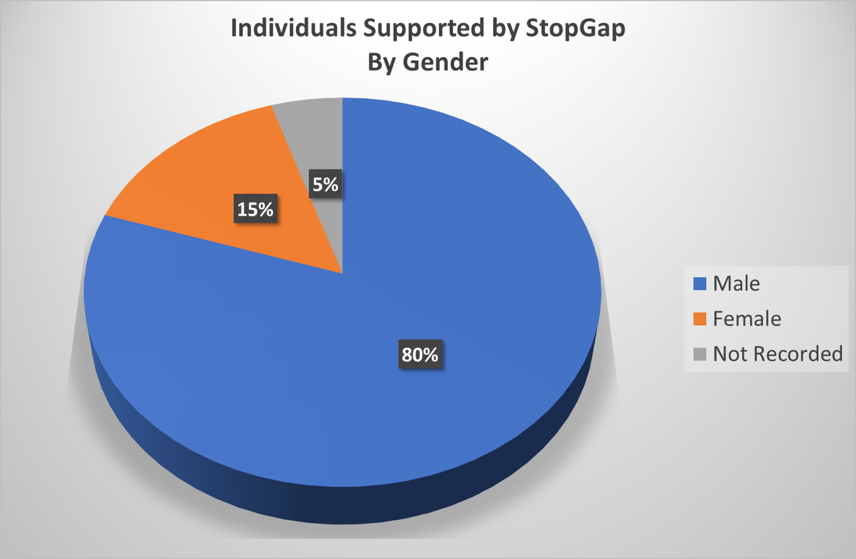

Over the last year, the majority of people using StopGap have been male at 80%

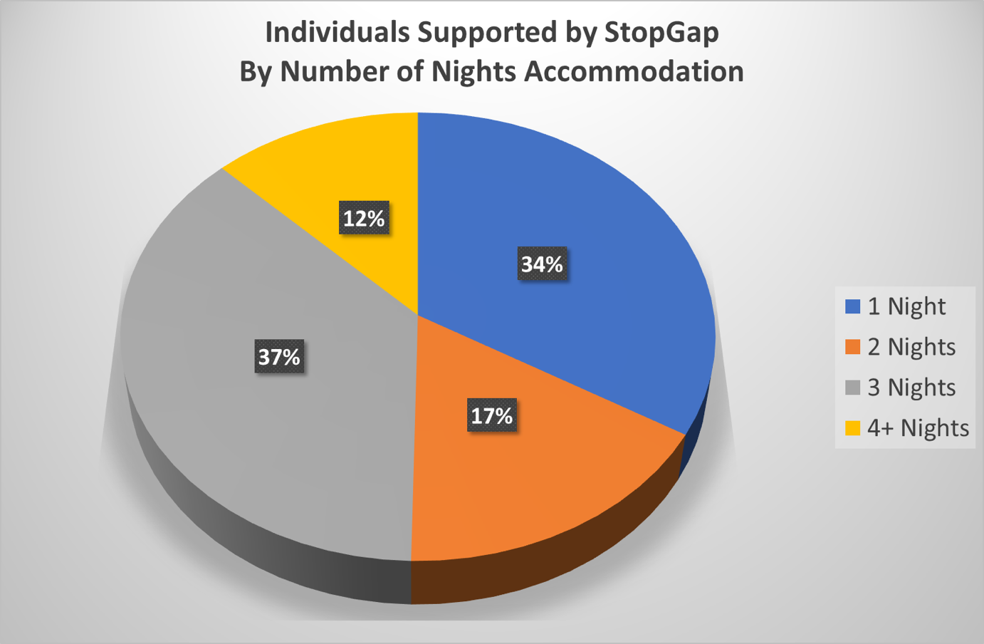

The majority of people who used StopGap had 3 nights at 37%, followed by 1 night at 34%

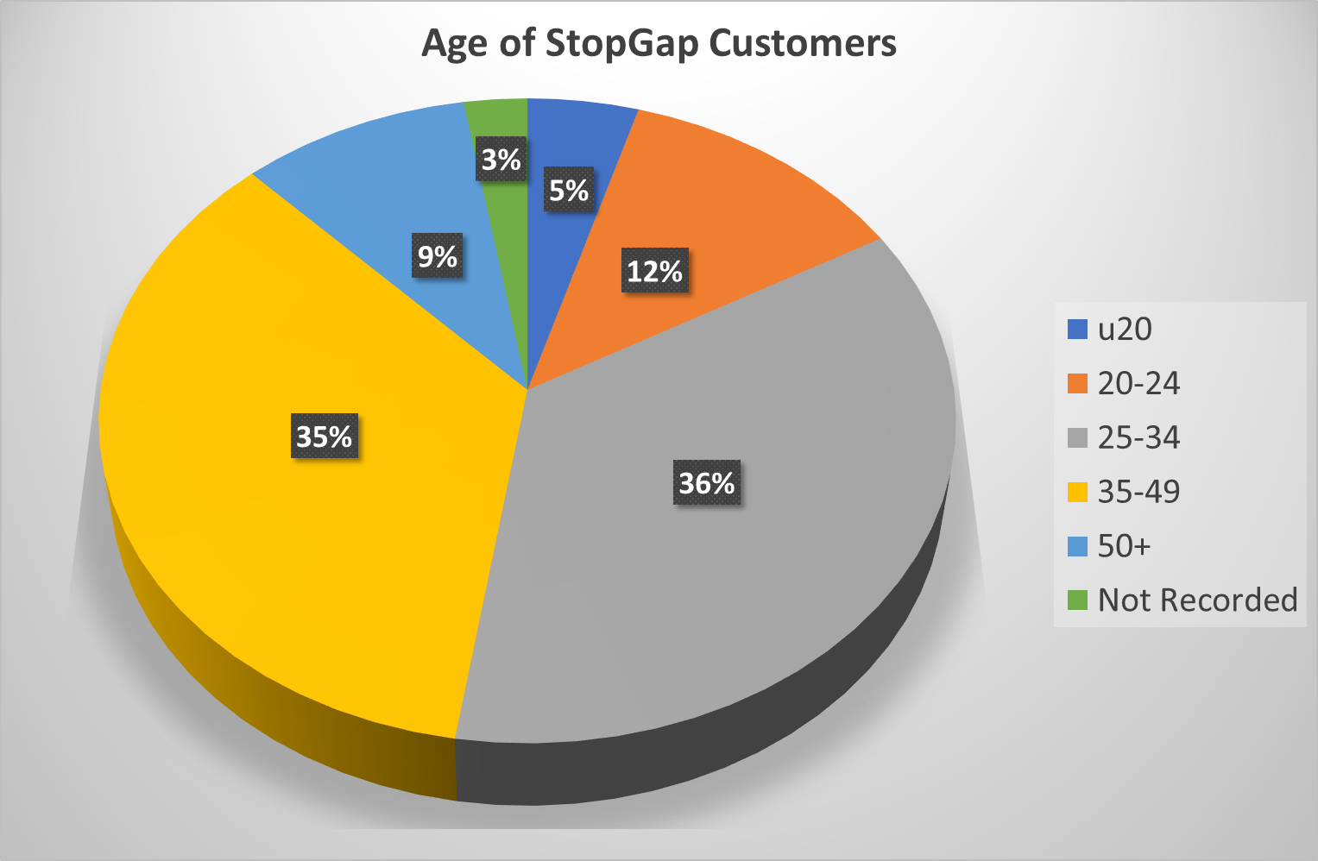

The majority of people accessing StopGap were aged between 25-34 years (at 36%). This is closely followed by age 35-49 years (at 35%), so 71% of all people using StopGap are 25-49 years old.

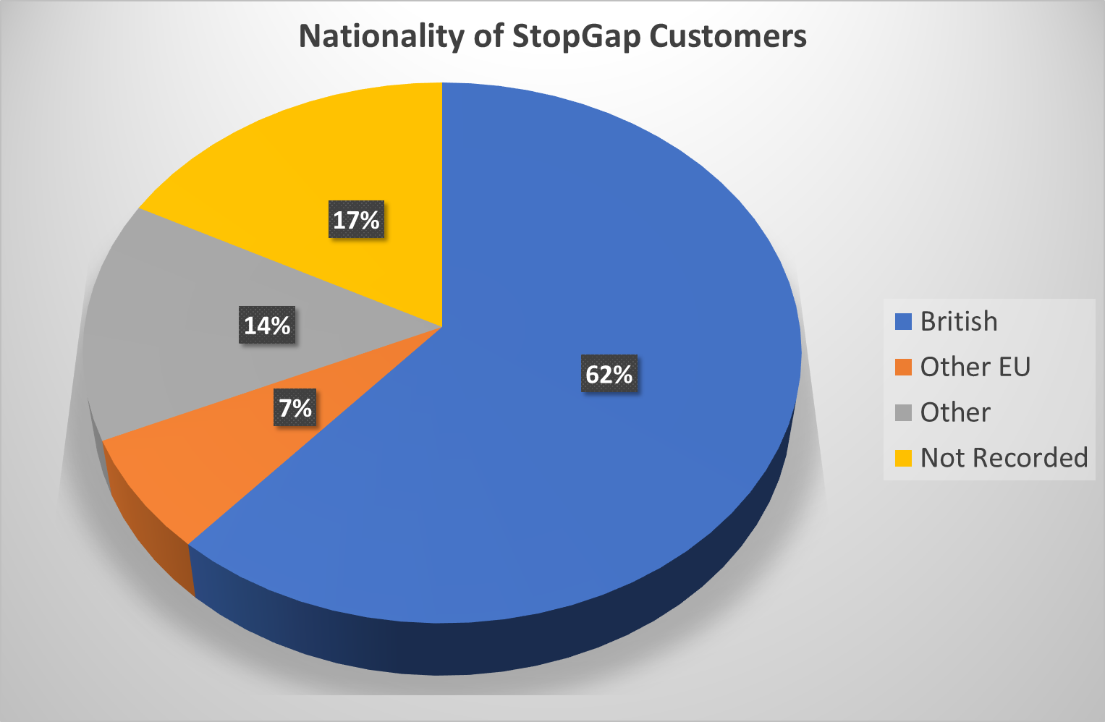
The majority of those people who told us their nationality were British at 62%. This has increased from 50% last year, which is a significant increase.
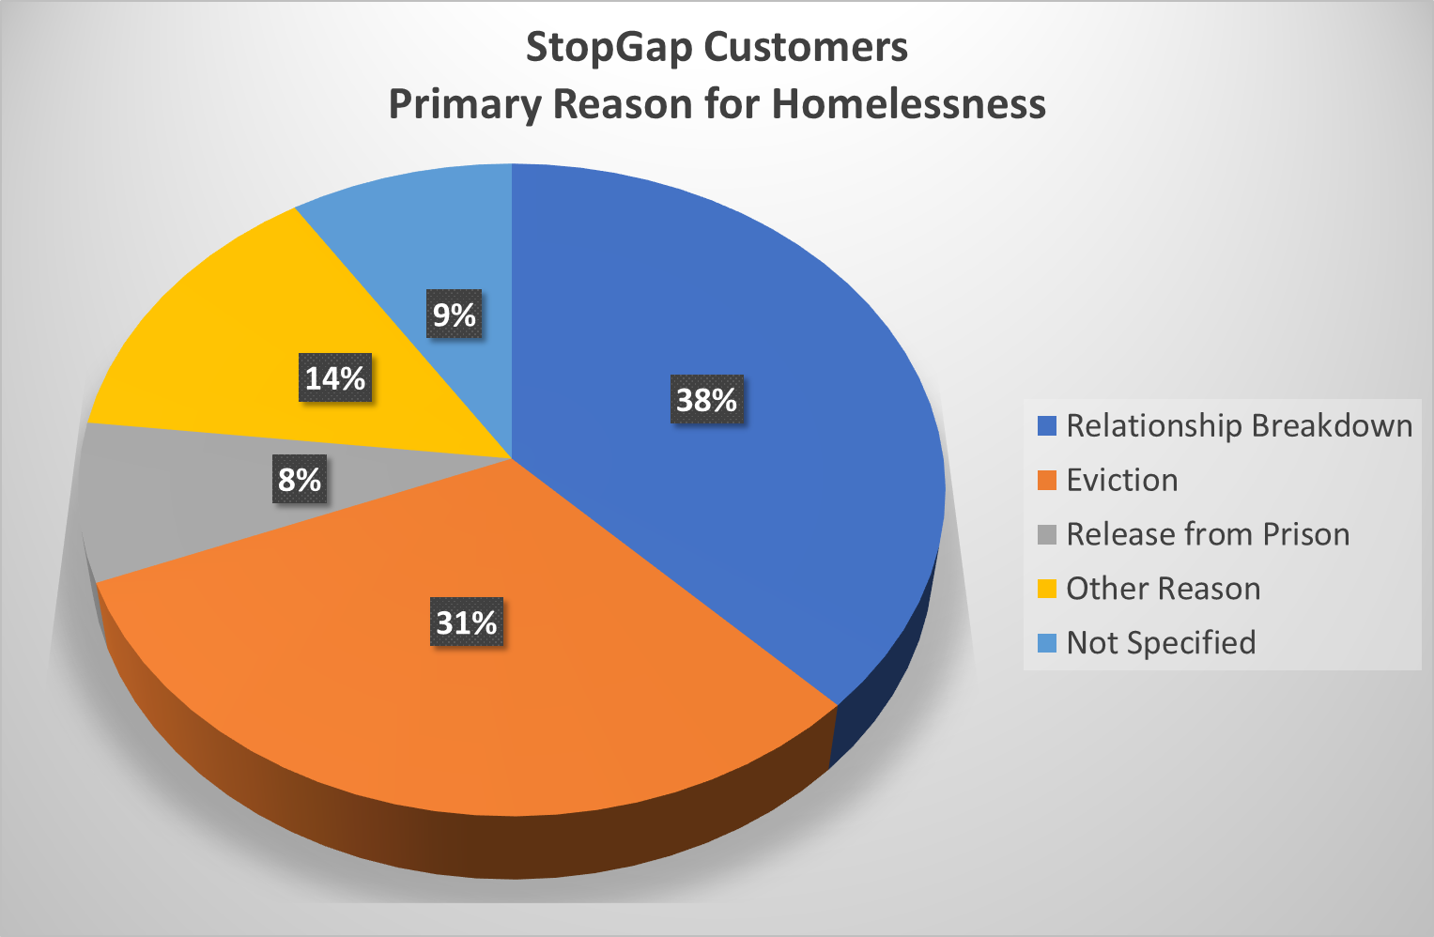
The majority of people using StopGap gave relationship breakdown (38%) and eviction (32%) as the reason for homelessness. Relationship breakdown has increased from 32% the previous year.

Summary:
As in previous years, for the majority of people, the main reasons for homelessness (where noted) were relationship breakdown (38%); closely followed by eviction (31%”). The reasons for the latter were usually not specified but probably included rent arrears. The last year we continued to have had a significant amount of “no shows” at our B&Bs , the reasons appear complex. Those that we know about include distance from the town centre and in some cases having to share a room. Unfortunately, in one-third of cases the reasons for homelessness were not recorded by the referral agency concerned.
The vast majority of referrals came via Framework's rough sleeper service on weekdays. However, other agencies, such as St Wilfrid's Centre, the Cathedral Archer Project, the Snowdrop Project, and ASSIST, can refer into Framework during office hours in order to access StopGap accommodation. There have been very infrequent out of hours referrals throughout the week from other agencies and from individual churches.
As in previous years, we have continued to give priority to those people who are most likely to be in a position to engage with services to increase their chances of obtaining longer-term accommodation in the near future. Statistics consistently show that a significant proportion of people that are seen are currently engaging with other services after accessing the StopGap scheme, principally by signing up to Framework's Rough Sleeper service.
Fundraising:
We continue a programme of fundraising throughout the year. We are grateful to individuals, churches, and a variety of voluntary sector organisations including :
5th August 2019 - £2k from J G Graves Trust
21st November 2019- £3k from Sheffield Town Trust

27th March 2020- £1k from Freshgate Trust
March 2020- £2,500 from Brelms as part of 3 year award
31st March 2020 - £10k from Awards for All
9th April 2020- £1,500 from Queen Victoria and Johnson Memorial Trust
26th May 2020 - £1k from Sir John Osborn Charitable Trust

Over the past few years we have been fortunate in being able to obtain sufficient funds from a variety of sources, such as those cited above, to sustain year-round operation for the foreseeable future. The accompanying financial statement shows continuing stability in our reserves. However, our fundraising programme may have to be tailored to take account of the decrease in overall demand for beds noted above, plus the scarcity of suitable B&B accommodation in the city.
Whatever the outcome of funding bids, as in previous years we would hope to be able to offer an all year emergency service for people who are judged to be most vulnerable: e.g. young men and especially young women aged between 18 and 21, or people over 60.
In addition to our usual appeals to religious groups and community organisations for donations and smaller grants, we plan to repeat our Sponsor a Bed campaign in the pre-Christmas period. This has highly successful in the past few years.
We aim to produce at least one newsletter or information update annually, generally in the late autumn, to precede a Christmas appeal. We also have a website (www.stopgapsheffield.org, ) through which it is possible to make online donations, as well as a Facebook page.
Other activities carried out over the last year:
Ruth Grayson stepped down from the Board of Trustees following the AGM in 2019
Tina Powell-Wiffen stepped down as treasurer following the 2019 AGM

Initiatives underway for the coming year 2020/21 include:
Working with Sheffield Hallam University students to Students to produce an updated report on the national rough sleeping situation, and then drill down to look at how this then impacts on us at a local level. It is anticipated that this will help with future newsletters and funding bids.

And finally:
Can I take this opportunity to thank our Independent Examiner, Dr Peter Cromar, who carries out a thorough job, voluntary, on our accounts.*
Thank you to all the homeless agencies that StopGap work with. StopGap couldn't do it without your help, knowledge and expertise
A big thank you must go to Liz Grasso StopGap’s part time administrator without whom I couldn't cope. Thank you.

* As of 20th January 2021 because of National Covid restrictions, Peter Cromar and the Treasurer of StopGap have not met, and so the finances are not audited. Both the Treasurer and Peter are liaising over this.

