StopGap Sheffield

Trustees’ Annual Report & Accounts

2018-2019

Trustees’ Annual Report and Financial Report
For the period 1 July 2018 to 30 June 2019

Registered charity number 1146601

Charity Reference and Administration

Registered Number: 1146601

Registered: 27 March 2012

Registered office:

Sheffield Cathedral

Church Street

Sheffield S1 1HA

Trustees (including officers):

Jo Abbott Chair

David Peers Vice chair

Louise Finnigan Secretary

Tina Powell-Wiffen Treasurer

Ruth Grayson

Souleymane Bah

Barney Williams - Registered with Charity Commission on 14/05/19

Timothy Renshaw

Amy Smith

Aimee Lowe

Administrator (part time):

Liz Grasso

Bankers:

Yorkshire Bank National Westminster Bank
Fargate 669 Ecclesall Road
Sheffield S1 1LL Sheffield S11 8PW

Note: Public Benefit:
In compiling this report and in exercising their powers and duties, the Trustees have had due regard to the guidance on public benefit published by the Charity Commission.

Structure, Governance and Management

Governing Document:

StopGap Sheffield is a Charitable Association whose constitution was adopted on the 4th October 2011 and amended by a Resolution passed at a Special General Meeting on the 28th February 2012.

Governance and Management:

The Charity and its property are managed and administered by trustees comprising its officers and other trustees elected at the last Annual General Meeting or co-opted during the year. All trustees must retire at each Annual General Meeting but are eligible for re-election. The day to day running of the Charity is the responsibility of its officers (the Chair, Secretary and Treasurer). The trustees meet regularly and receive reports from the officers and from other appropriate persons on the operations of the Charity, its finances, fundraising and governance. The trustees take decisions regarding strategic and policy direction, significant items of expenditure and other major issues.

Objectives, Activities and Achievements

Charitable Objectives:
The objectives of StopGap Sheffield (hereinafter referred to as StopGap), as stated in its constitution, are 'the relief of poverty of the homeless, temporary homeless and rough sleepers in the City of Sheffield by the provision of overnight emergency accommodation and related support services.

Method of operation:
StopGap arranges and pays for short-term overnight accommodation in Sheffield for those who may otherwise find themselves on the streets or sleeping rough. Accommodation is in private B&Bs approved both by Sheffield City Council and ourselves. We do not possess, hire, or otherwise provide our own accommodation. StopGap liaises closely with various local voluntary sector agencies accepting referrals from them of individuals as appropriate (and subject to availability in all cases), usually for one night at a time and usually for a maximum of 3 nights per individual within any six-month period. Individuals are asked to report back to the referral agency, or to another appropriate agency, the following day; and must be re-referred by an appropriate agency for a subsequent night's stay. StopGap itself does not select, engage with or interview people directly. The referral process is run via a mobile phone. For most of the current year this was done by our part-time administrator, assisted by a rota drawn from our volunteer trustees. We have no office or permanent staff, other than a part-time administrator as circumstances permit, and currently have no other volunteers.
Achievements for the year 1 July 2018 to 30 June 2019:
Originally, StopGap operated during the winter months only. The Trustees have decided to maintain a commitment to year-round operation and have tailored a fundraising programme accordingly. In the event of a funding shortfall, which has never yet occurred, trustees have stated that priority should be given to winter provision and to supporting those individuals at any time of year deemed to be most vulnerable, especially young women.

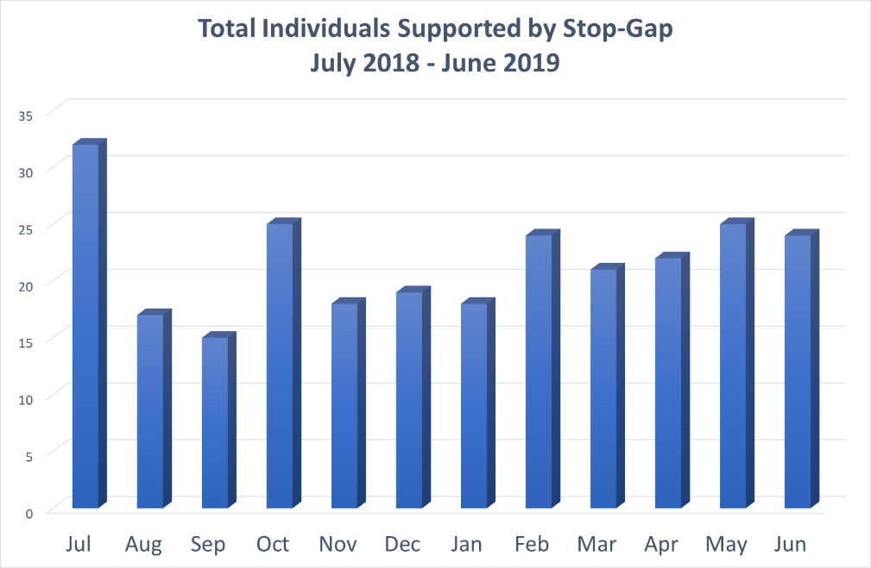

During the 12-month period from 1 July 2018 to 30 June 2019, StopGap provided a total of 632 bednights for a total of 260 individuals: an average stay of slightly over two nights per individual.

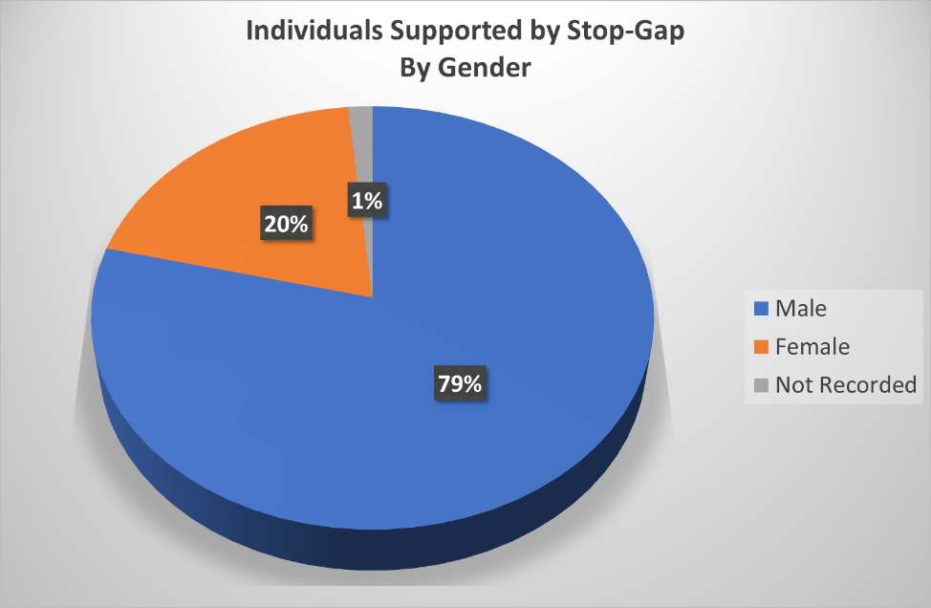
The majority of individuals supported by Stop-Gap were men,
but women accounted for 20% of people helped.

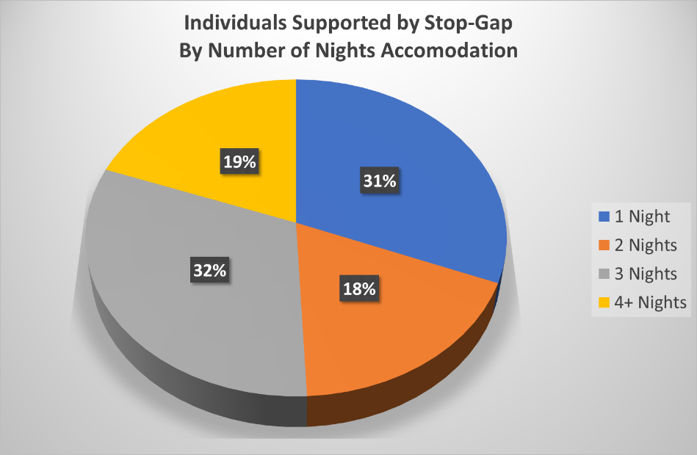
Nearly one in five people were accommodated for four or more nights.

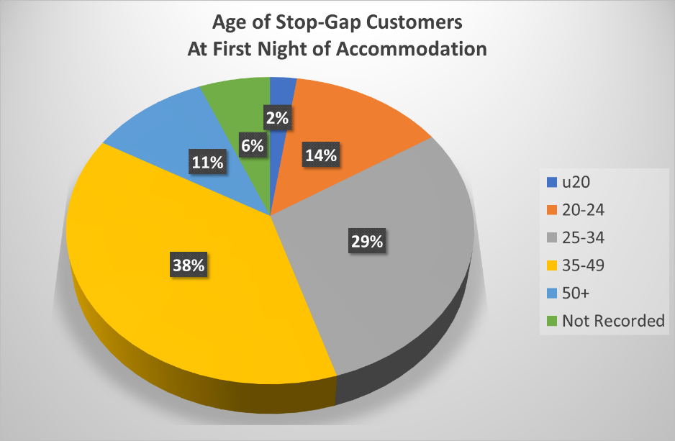
Most, but not all, were aged between 25 and 49.

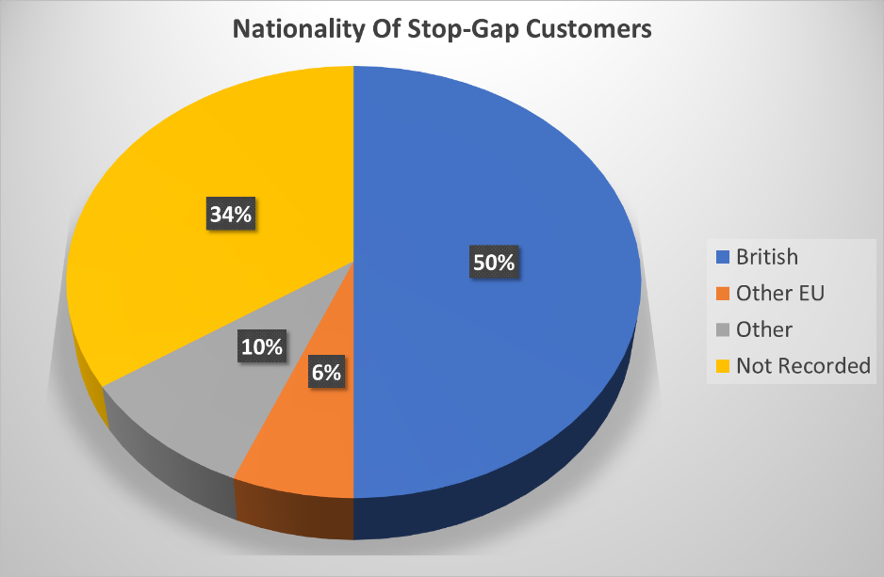
The majority of those who told us their nationality were British – but we don’t have information for a third of these people.

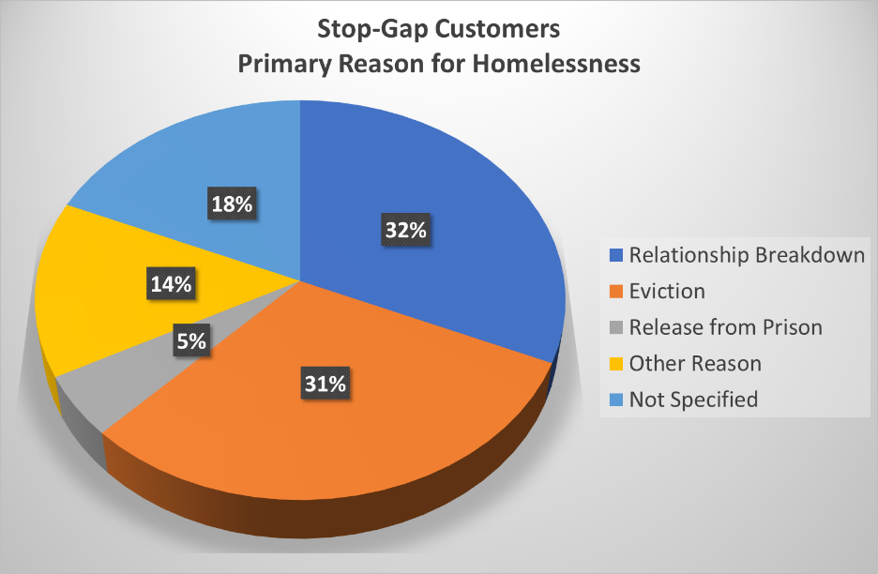
The most often given reasons for being homeless were relationship breakdown and eviction.

As in previous years, for the majority of people, the main reasons for homelessness (where noted) were relationship breakdown (32%); closely followed by eviction (31%). The reasons for the latter were usually not specified but probably included rent arrears. The last year we have had a significant amount of “no shows” at our B&Bs , the reasons appear complex. Those that we know about include distance from the town centre and in some cases having to share a room. Unfortunately, in one-third of cases the reasons for homelessness were not recorded by the referral agency concerned.
The vast majority of referrals came via Framework's rough sleeper service on weekdays. However, other agencies, such as St Wilfrid's Centre, the Cathedral Archer Project, the Snowdrop Project, and ASSIST, can refer into Framework during office hours in order to access StopGap accommodation. There have been very infrequent out of hours referrals throughout the week from other agencies and from individual churches.
As in previous years, we have continued to give priority to those people who are most likely to be in a position to engage with services to increase their chances of obtaining longer-term accommodation in the near future. Statistics consistently show that a significant proportion of people that are seen are currently engaging with other services after accessing the StopGap scheme, principally by signing up to Framework's Rough Sleeper service.
During the winter of 2018/19 Sheffield piloted a Safe Place initiative for 6 weeks. This was evaluated and hopefully will be repeated over the winter of 2019/20. It will be interesting to see if this initiative has an impact on Stop Gap referrals.
Fundraising:
We continue a programme of fundraising throughout the year. We are grateful to individuals, churches, and a variety of voluntary sector organisations including :
9/7/18- £3k from Give As you Rent at Sheffield Uni
9/8/18- £2k from J G Graves Trust
12/3/19- 3-year award of £7.5k from Brelms Trust
15/3/19- £2.5k from Freshgate Trust
12/4/19-£2k from Queen Victoria and Johnson Trust
15/5/19- £1k from Sir John Osborn Charitable Trust

Over the past few years we have been fortunate in being able to obtain sufficient funds from a variety of sources, such as those cited above, to sustain year-round operation for the foreseeable future. The accompanying financial statement shows continuing stability in our reserves.
Whatever the outcome of funding bids, as in previous years we would hope to be able to offer an all year emergency service for people who are judged to be most vulnerable: e.g. young men and especially young women aged between 18 and 21, or people over 60.
In addition to our usual appeals to religious groups and community organisations for donations and smaller grants, we plan to repeat our 'Give A Bed' campaign in the pre-Christmas period. This has highly successful in the past few years.
We aim to produce at least one newsletter or information update annually, generally in the late autumn, to precede a Christmas appeal. We also have a website (www.stopgapsheffield.org, ) through which it is possible to make online donations, as well as a Facebook page.
Other activities carried out over the last year:
This year Stop Gap have changed the donation site to VirginMoneyGiving
The Stop Gap emergency mobile phone has had to be replaced as the original ones fell to bits.
Stop Gap Trustees have accepted and welcomed Mr Barney Williams onto the Board. Barney, if approved at the AGM, is willing to take on the role of Treasurer as Tina Powell - Wiffen wishes to stand down.

Initiatives underway for the coming year 2020/21 include:
Working with Sheffield Hallam University students to both:
- Update our web site to make it more informative and easier to navigate
- Conduct a literature search on homelessness in the UK with a specific emphasis on Sheffield. This can then be used in future funding bids.
And finally
Can I take this opportunity to thank our Independent Examiner, Dr Peter Cromar, who carries out a thorough job, voluntary, on our accounts.
Thank you to all the homeless agencies that StopGap work with. StopGap couldn't do it without your help, knowledge and expertise
A big thank you must go to Liz Grasso StopGap’s part time administrator without whom I couldn't cope. Thank you.

